Document Loaders in LangChain
https://www.youtube.com/watch?v=bL92ALSZ2Cg&list=PLKnIA16_RmvaTbihpo4MtzVm4XOQa0ER0&index=12
https://github.com/campusx-official/langchain-document-loaders
00:00 – Intro
00:59 - AI auto dubbing feature
02:22 - Recap
03:50 - What is RAG?
08:30 - RAG components
10:56 - Document Loaders in LangChain
13:15 - Text Loader
22:02 - PyPDFLoader
26:50 - Limitations
29:43 - Directory Loader
37:22 - Load vs Lazy Load
42:19 - WebBaseLoader
49:37 - CSVLoader
52:33 - Other Document Loaders
54:35 - Custom Document Loader
Document Loaders in LangChain

1. Introduction to the LangChain RAG Series
The instructor introduces the continuation of the LangChain playlist.
Originally, the plan was to cover the Memory component after Chains and Runnables. However, after research, it was observed that LangChain is gradually moving the Memory feature into LangGraph.
Because of this:
- The Memory component will be taught later along with LangGraph
- A new topic is starting now: RAG-based (Retrieval-Augmented Generation) applications using LangChain
The focus of upcoming videos will be on building real-world RAG applications.

3. Recap of LangChain Fundamentals Covered So Far
Two major areas were covered in previous videos:
3.1 LangChain Components
Including:
- Models
- Prompts
- Chains
- Other core building blocks
Each component was explained with hands-on coding.
3.2 LangChain Core Concepts
Special focus was given to:
- Runnables (covered across multiple videos)
- Understanding how LangChain workflows are built
At this stage, learners are considered ready to build LLM-based applications using LangChain.

4. Introduction to RAG (Retrieval-Augmented Generation)
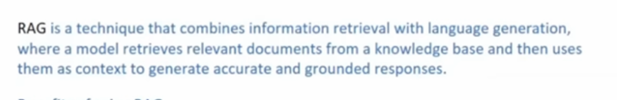
4.1 What is RAG?
RAG is a technique that combines:
- Information Retrieval
- Language Generation
In simple terms:
An LLM retrieves relevant data from an external knowledge source and then uses it to generate accurate responses.

4.2 Limitations of Normal Chatbots like ChatGPT
Chatbots may fail when:
- Asking about current events (model trained on past data)
- Asking about personal documents (emails, company files, PDFs)
- Querying private or confidential data
The LLM simply does not have access to this information.

4.3 How RAG Solves These Problems
In RAG-based systems:
- You connect the LLM to an external knowledge base such as:
  - Company databases
  - PDFs
  - Text files
  - Personal documents
When a user asks a question:
- Relevant data is retrieved from the knowledge base
- That data is sent as context to the LLM
- The LLM generates an accurate response

4.4 Key Benefits of RAG
- Access to up-to-date information
- Privacy (no need to upload sensitive data to public chatbots)
- No document size limitation (large files can be chunked and processed)
- Better accuracy and grounding
This is why RAG is a major trend in modern AI applications.

5. Core Components of a RAG Application
A typical RAG pipeline consists of:
- Document Loaders
- Text Splitters
- Vector Databases
- Retrievers
These four components together form almost every RAG system.
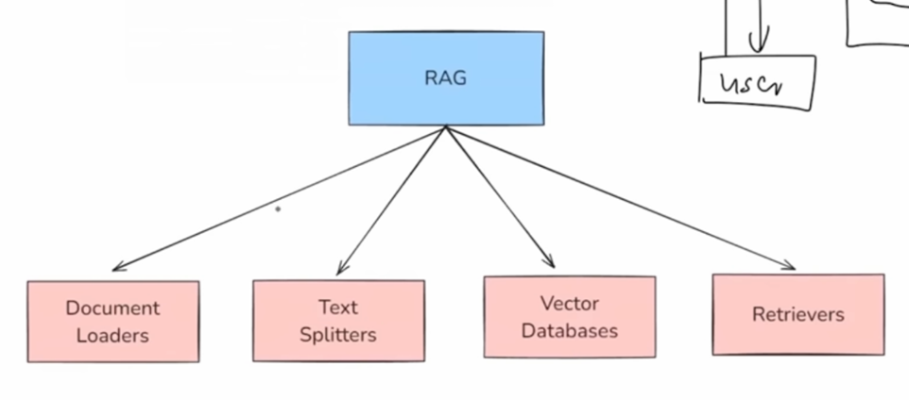

6. Focus of This Video: Document Loaders
This video specifically covers:
- Document Loaders in LangChain
Since LangChain has hundreds of loaders:
- The instructor will explain the core principle
- Demonstrate the most commonly used loaders:
Main loaders covered:
- Text Loader
- PDF Loader
- Web Loader
- CSV Loader
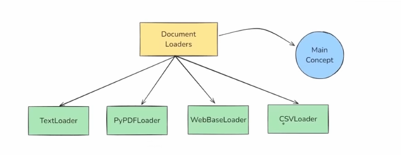
Other loaders will be briefly discussed.
Important point:
All document loaders follow the same basic concept.
Once you understand one, others become easy.

7. What Are Document Loaders in LangChain?
7.1 Definition
Document Loaders are LangChain components used to:
- Load data from various sources
- Convert it into a standardized format called Document objects
These documents are then used for:
- Chunking
- Embedding
- Retrieval
- Generation

7.2 Why Document Loaders Are Needed
Data can exist in many formats:
- Text files
- PDFs
- Databases
- Cloud storage
- Web pages
LangChain ensures:
- All data is converted into a common format
- So, it can be processed uniformly

7.3 Document Object Structure
Each Document object contains:
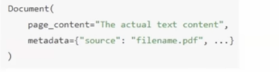
- Page Content
  - The actual text/data
- Metadata
  - Source
  - File path
  - Creation time
  - Author
  - Other contextual information
This structure allows flexible processing later.

8. Text Loader in LangChain
8.1 Purpose of Text Loader
Text Loader is the simplest document loader.
It is used to:
- Load plain text files
- Convert them into Document objects
Common use cases:
- Log files
- Code snippets
- Transcripts
- Simple text documents

8.2 Importing Text Loader
All document loaders are available in:
langchain_community.document_loaders
Example:
- Import TextLoader from the community package

8.3 Creating a Text Loader Object
Steps:
- Create a loader instance
- Provide:
  - File path
  - Encoding (optional, e.g., UTF-8)
Example scenario:
- A file named cricket.txt containing a poem

8.4 Loading the Document
Call:
loader.load()
These returns:
- A list of Document objects
Important:
Every document loader always returns a list of documents, even if there is only one file.

8.5 Understanding the Output
The output is:
- A Python list
- Each element is a Document object
Example:
docs[0]
This gives a single Document.
Each Document contains:
- docs[0].page_content
- docs[0].metadata

8.6 Using Loaded Content with an LLM
The loaded text can be:
- Passed directly into a LangChain chain
- Used for summarization, Q&A, or other tasks
Example flow:
- Extract page content
- Send it to an LLM via prompt
- Parse output using StringOutputParser
This shows how seamlessly document loaders integrate with LangChain pipelines.
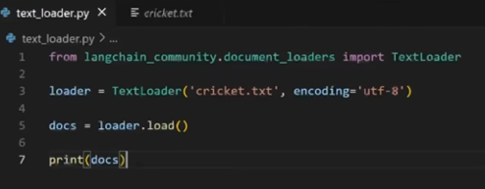
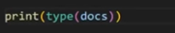
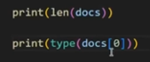
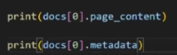

9. Key Takeaways from Text Loader
- All loaders return a list of Document objects
- Each Document has:
  - page_content
  - metadata
- Loaded data can be directly connected to LLM chains
- The same pattern applies to other loaders (PDF, web, CSV, etc.)

10. PyPDFLoader in LangChain
10.1 Purpose of PyPDFLoader
PyPDFLoader is a document loader in LangChain used to:
- Read PDF files
- Convert them into Document objects
Its main feature is that it works on a page-by-page basis.
This means:
If a PDF has 25 pages, PyPDFLoader will generate:
- 25 separate Document objects
- One for each page
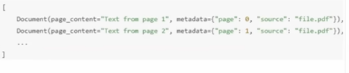
So after processing, you will receive a list containing one Document per page.

10.2 How PyPDFLoader Processes PDFs
Each page becomes a Document object containing:
- Page Content
  - Text from that specific page
- Metadata
  - Page number
  - Source file
  - Creation details
  - Total pages
This allows:
- Easy chunking
- Better retrieval
- Precise reference tracking

10.3 Internal Working of PyPDFLoader
PyPDFLoader internally uses the PyPDF library.
Because of this:
- It works best with simple text-based PDFs
- It does not perform well with:
  - Scanned image PDFs
  - Complex layouts
For scanned or layout-heavy PDFs, other loaders are recommended.

10.4 Installing Required Library
Before using PyPDFLoader, you must install:
pip install pypdf
Without this, the loader will not work.

10.5 Basic Usage of PyPDFLoader
Steps:
- Import PyPDFLoader from:
- langchain_community.document_loaders
- Create a loader object with the PDF file path
- Call:
- loader.load()
- Store the output in a variable (usually named docs)
This returns a list of Document objects.

10.6 Example Output Explanation
If the PDF contains 23 pages:
- The returned list will contain 23 Document objects
To check:
len(docs)
Output will be:
23

10.7 Accessing Individual Pages
To get the content of the first page:
docs[0].page_content
To get metadata:
docs[0].metadata
Metadata typically includes:
- Producer name
- Creator name
- Creation date
- Source file
- Total pages
- Current page number
This confirms that each page is treated independently.
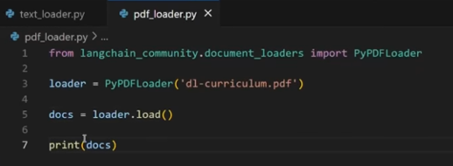
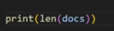
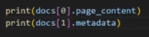

11. Limitations of PyPDFLoader
PyPDFLoader is not the only PDF loader in LangChain.
It is best suited when:
- PDFs contain mostly textual data
However, it struggles in cases such as:
- Scanned PDFs (image-based)
- Complex table structures
- Layout-heavy documents

11.1 Alternative PDF Loaders in LangChain
LangChain provides several specialized loaders:
- PDFPlumberLoader
  - Best for extracting tabular data
- UnstructuredPDFLoader
  - Good for scanned PDFs and structured extraction
- AmazonTextractPDFLoader
  - Useful for OCR-based extraction
- PyMuPDFLoader
  - Handles complex layouts better
Each loader supports:
- load()
- lazy_load()
✅ load()
- Loads all documents at once into memory
- Returns a list of document objects immediately
- Faster for small datasets
Example behavior:
👉 Reads the entire file(s) in one go and stores everything
Pros:
- Simple to use
- Immediate access to all documents
Cons:
- High memory usage for large files or many documents

✅ lazy_load()
- Loads documents one by one (on demand)
- Returns an iterator/generator instead of a full list
- Best for large datasets
Example behavior:
👉 Loads the next document only when you loop over it
Pros:
- Memory efficient
- Scales well for large data
Cons:
- Slightly slower since loading happens gradually
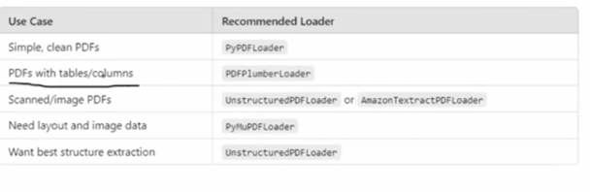

11.2 Choosing the Right Loader
You do NOT need to learn every loader.
Best practice:
- Understand the basic concept
- Choose the loader based on your project needs
LangChain documentation provides:
- Use cases for each loader
- Implementation examples

12. DirectoryLoader in LangChain
12.1 Why DirectoryLoader is Needed
So far, we loaded:
- A single text file
- A single PDF file
But in real-world scenarios, we often have:
- A folder containing multiple documents
Examples:
- Many PDFs
- Many text files
DirectoryLoader helps load multiple documents from a directory at once.

12.2 How DirectoryLoader Works
DirectoryLoader:
- Takes a folder path
- Selects files using a pattern (glob)
- Uses a specific loader for each file type

12.3 Required Imports
You need:
- DirectoryLoader
- A specific loader (e.g., PyPDFLoader)
From:
langchain_community.document_loaders

12.4 Important Parameters of DirectoryLoader
- Directory Path
  - Location of folder containing documents
- Glob Pattern
  - Specifies which files to load
Examples:
- *.pdf → load all PDF files
- **/*.txt → load all text files from subfolders
- data/*.csv → load all CSV files from data folder
- Loader Class
  - Defines how each file should be read (e.g., PyPDFLoader)

12.5 Loading Multiple PDFs Example
Process:
- Create DirectoryLoader object
- Provide:
  - Folder path (e.g., "books")
  - Glob pattern (*.pdf)
  - Loader class (PyPDFLoader)
- Call:
loader.load()

12.6 Understanding the Output
Suppose:
- PDF 1 → 326 pages
- PDF 2 → 392 pages
- PDF 3 → 468 pages
Total Document objects:
326 + 392 + 468 = 1186
So:
len(docs) = 1186
Each page from every PDF becomes a separate Document.

12.7 Accessing Pages from Multiple PDFs
First document (first page of first PDF):
docs[0]
Last page of first PDF:
docs[325]
First page of second PDF:
docs[326]
Metadata helps identify:
- Which PDF the page belongs to
- Total pages in that file
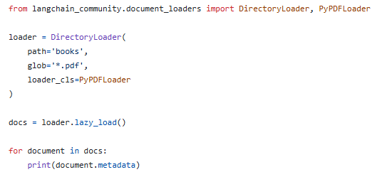
In the above example if we use load() instead of lazy_load() then everything loaded at once and time taken will be more

13. Performance Issues with Bulk Loading
When loading many large PDFs together:
Problem 1: Slow Loading Time
- Loading multiple large files takes significant time
Problem 2: High Memory Usage
- All documents are loaded into RAM at once
- This becomes impractical for:
  - Hundreds of PDFs
  - Very large datasets

14. Introduction to Lazy Loading (Preview)
To solve:
- Slow loading
- Memory overflow
LangChain provides:
Lazy Loading
Instead of:
- Loading everything into memory at once
It:
- Loads documents one by one when needed
This improves:
- Performance
- Scalability
(The detailed explanation continues in the next section of the video.)

15. Load vs Lazy Load in LangChain
Every document loader in LangChain provides two important methods:
- load()
- lazy_load()
Both are used to load documents, but they work very differently.

15.1 Eager Loading using load()
The load() function performs eager loading.
This means:
- All documents are loaded into memory at once
- A complete list of Document objects is returned
Example scenario:
If a PDF contains 500 pages:
- load() will:
  - Create 500 Document objects
  - Load all 500 into RAM at the same time
  - Return a list of 500 documents
When to use load()
Use eager loading when:
- Number of documents is small
- Files are not too large
- You want everything in memory at once
Examples:
- One or two PDFs
- Small text files

15.2 Lazy Loading using lazy_load()
The lazy_load() function performs lazy loading.
Instead of returning a full list, it returns a:
👉 Generator of Document objects
This generator:
- Loads one document at a time into memory
- Allows processing
- Then removes it from memory
- Moves to the next document
How it works:
If a PDF has 500 pages:
- It does NOT load all 500 pages together
- It loads:
  - Page 1 → process → release
  - Page 2 → process → release
  - And so on

15.3 Key Differences Between Load and Lazy Load
Feature | load() | lazy_load()
Loading type | Eager | On-demand
Memory usage | High | Low
Return type | List of documents | Generator
Performance | Slower for large datasets | Efficient
Best for | Small datasets | Large datasets

15.4 Practical Demonstration Insight
With load():
- Program waits first
- Loads all documents
- Then starts processing
With lazy_load():
- Processing starts immediately
- Each document is handled one by one
- No long waiting time upfront

15.5 When to Use Lazy Loading
Use lazy_load() when:
- Working with many PDFs
- Working with large datasets
- Memory is limited
- Streaming-style processing is needed

16. WebBaseLoader in LangChain
16.1 Purpose of WebBaseLoader
WebBaseLoader is used to:
- Load textual content from web pages
- Convert it into Document objects
It allows you to:
- Extract website content
- Ask questions over web data using LLMs

16.2 How WebBaseLoader Works Internally
WebBaseLoader uses two Python libraries:
- Requests
  - Sends HTTP requests to fetch the webpage
- BeautifulSoup
  - Parses HTML
  - Extracts text content
This removes:
- HTML tags
- Layout structure
And returns clean text.

16.3 Best Use Cases
Works well with:
- Static websites
- Blogs
- News articles
- Public informational pages

16.4 Limitations
Does NOT work well with:
- JavaScript-heavy dynamic websites
- Pages requiring user interaction
For such cases, LangChain provides:
- SeleniumURLLoader

16.5 Basic Usage Flow
Steps:
- Import WebBaseLoader
- Create loader object with URL
- Call loader.load()
- Store result in docs

16.6 Output Behavior
If you load:
- A single URL
You receive:
- One Document object
If you pass:
- A list of URLs
You receive:
- One Document per URL

16.7 Using Web Content with an LLM
Once loaded:
- Extract docs[0].page_content
- Pass it into a LangChain chain
- Ask questions over website content
Example queries:
- Product details
- Specifications
- Article summary

16.8 Real-World Project Idea
A possible application:
- Chrome extension that:
  - Loads current webpage content
  - Allows chatting with the page using an LLM
Workflow:
- Chrome plugin frontend
- Backend API using LangChain
- WebBaseLoader loads content
- LLM answers user queries in real time
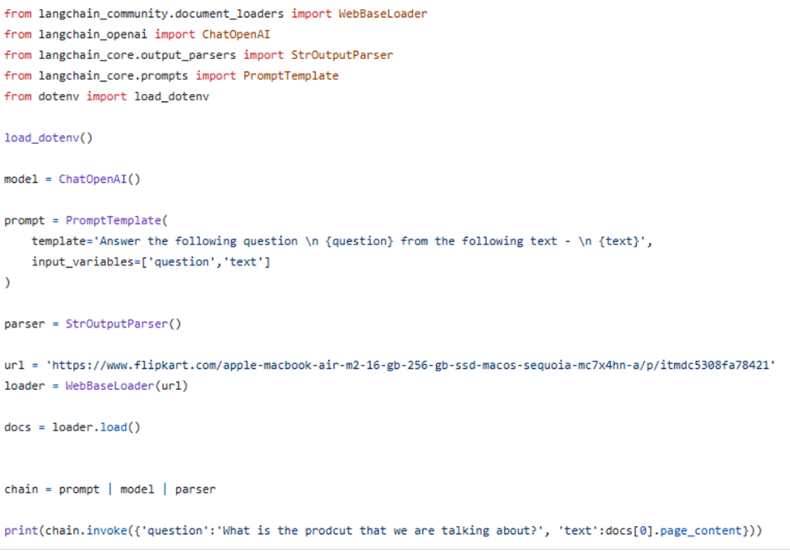

17. CSVLoader in LangChain
17.1 Purpose of CSVLoader
CSVLoader is used to:
- Load CSV files into LangChain
- Convert each row into a Document object
This is useful when:
- Working with structured data
- Performing LLM-based data analysis

17.2 How CSVLoader Processes Data
If a CSV file contains:
- 400 rows
CSVLoader will create:
- 400 Document objects
Each row becomes one document.

17.3 Structure of Each CSV Document
Each Document contains:
Page Content
- A string with:
- column_name: value
for each column in the row
Metadata
- Source file
- Row number

17.4 Example Output Behavior
First row:
docs[0]
Second row:
docs[1]
Each shows:
- Row data in page_content
- Row index in metadata

17.5 Lazy Loading with CSV Files
CSVLoader also supports:
- lazy_load()
Useful when:
- CSV file is very large
This allows:
- Row-by-row processing
- Low memory usage

17.6 Common Use Cases
- Asking analytical questions
- Finding max/min values
- Filtering data logically
- Summarizing datasets
Example questions:
- Which column has the highest value?
- How many purchases happened?
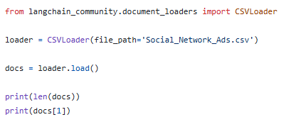

18. Summary of Major Document Loaders Covered
The main loaders discussed:
- TextLoader
- PyPDFLoader
- DirectoryLoader
- WebBaseLoader
- CSVLoader
These cover most real-world use cases.

19. Other Document Loaders in LangChain
19.1 Overview
LangChain provides a very large collection of built-in document loaders organized into well-defined categories.
These categories include loaders for:
- Web pages
- PDFs
- Cloud storage services
- Social platforms
- Messaging services
- Productivity tools
- Common file formats
Instead of just a few loaders, LangChain supports many real-world data sources.

19.2 Web Page Related Loaders
Under the web category, LangChain includes loaders such as:
- WebBaseLoader (already discussed)
- Unstructured Sitemap Loader
- HyperBrowser Loader
- AgentQL Loader
These help in loading:
- Website pages
- Multiple web URLs
- Structured and unstructured web data

19.3 PDF Related Loaders
For PDF files, LangChain provides multiple loaders depending on:
- File structure
- Scanned vs text PDFs
- Advanced parsing needs
Examples include:
- PyPDFLoader
- Other specialized PDF loaders

19.4 Cloud Storage Loaders
LangChain supports loading data from cloud services such as:
- Amazon S3
- Microsoft Azure
- Dropbox
- Google Drive
These loaders allow you to:
- Directly fetch documents from cloud storage
- Avoid manual downloads

19.5 Social and Messaging Platform Loaders
There are loaders for:
- Social media platforms
- Messaging services
These help in loading:
- Chat data
- Messages
- Platform-specific content

19.6 Productivity Tool Loaders
LangChain also includes loaders for tools such as:
- Git repositories
- Other productivity software
This helps in working with:
- Codebases
- Documentation stored in tools

19.7 Common File Type Loaders
Examples include:
- CSVLoader (already discussed)
- DirectoryLoader
- JSONLoader
- TextLoader
LangChain supports almost every commonly used file format.

19.8 YouTube Transcript Loader
There is a specific loader for:
- YouTube video transcripts
This allows you to:
- Load subtitles/transcripts
- Use them in RAG pipelines
- Ask questions over video content

19.9 How to Learn About Each Loader
LangChain documentation provides:
- Complete list of loaders
- Use cases
- Sample code for each loader
Recommended approach:
- Do NOT try to learn all loaders at once
- Learn loaders based on project needs
Example:
If your project requires YouTube transcripts:
→ Read only the YouTube loader documentation
Otherwise:
→ Skip it for now

19.10 Key Learning Strategy
Focus on:
- Important loaders first (Text, PDF, Directory, Web, CSV)
- Learn others only when needed
This saves time and improves practical understanding.

20. Custom Document Loader in LangChain

20.1 Why Custom Loaders Are Needed
Sometimes your data source may be:
- Unique
- Not supported by LangChain
In such cases:
👉 You can create your own custom document loader.

20.2 LangChain’s Extensibility Feature
LangChain allows developers to:
- Build their own loaders
- Plug them into the framework
This is why LangChain has so many loaders today.

20.3 How Custom Loaders Are Created
To create a custom document loader:
- Create a new class
- Inherit from the BaseLoader class
- Implement:
  - load() method
  - or lazy_load() method
- Add your custom data processing logic

20.4 Example Concept (High-Level)
Your custom loader class will:
- Fetch data from your custom source
- Convert it into Document objects
- Return them for LangChain usage

20.5 Community Contribution Model
Most existing loaders in LangChain:
- Were created by community developers
- Based on real-world use cases
That is why:
- They are part of the langchain_community package
Over time:
- The pool of loaders has grown significantly

20.6 When to Build Your Own Loader
Create a custom loader when:
- Your data source is not available
- Existing loaders don’t meet your needs
- You need special preprocessing logic

20.7 Advantage of Custom Loaders
- Full flexibility
- Can support any data source
- Integrates smoothly into LangChain workflows

21. Final Conclusion of Document Loaders Topic
In this video, we learned:
- What RAG is
- Components of RAG
- Role of Document Loaders
- Popular built-in loaders
- Load vs Lazy Load
- Web and CSV loading
- Many other loaders
- How to build custom loaders

Key Takeaway
You do NOT need to memorize every loader.
Instead:
- Understand the core concepts
- Learn loaders as per project requirements
LangChain gives you:
- Ready-made loaders
- Flexibility to create your own

